Student: Alan Danque

Professor: Anthony Armstrong

Week 2 Exercise: 3 line charts, 3 step charts using Python, R and Tableau

Created using Tableau

Git Repo Location:

<https://github.com/adanque/DSC640>

All Python, R and Tableau twb scripts and dataset & generated plots are located on this Repo:

<https://github.com/adanque/DSC640/tree/master/Week2>

Line Chart

Python

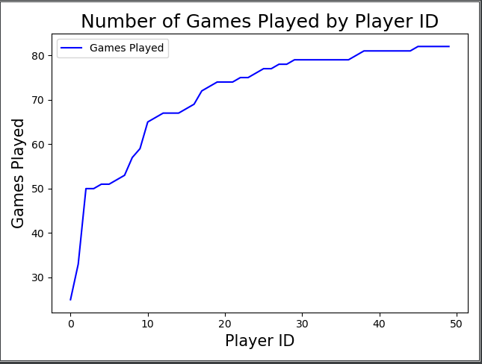

R

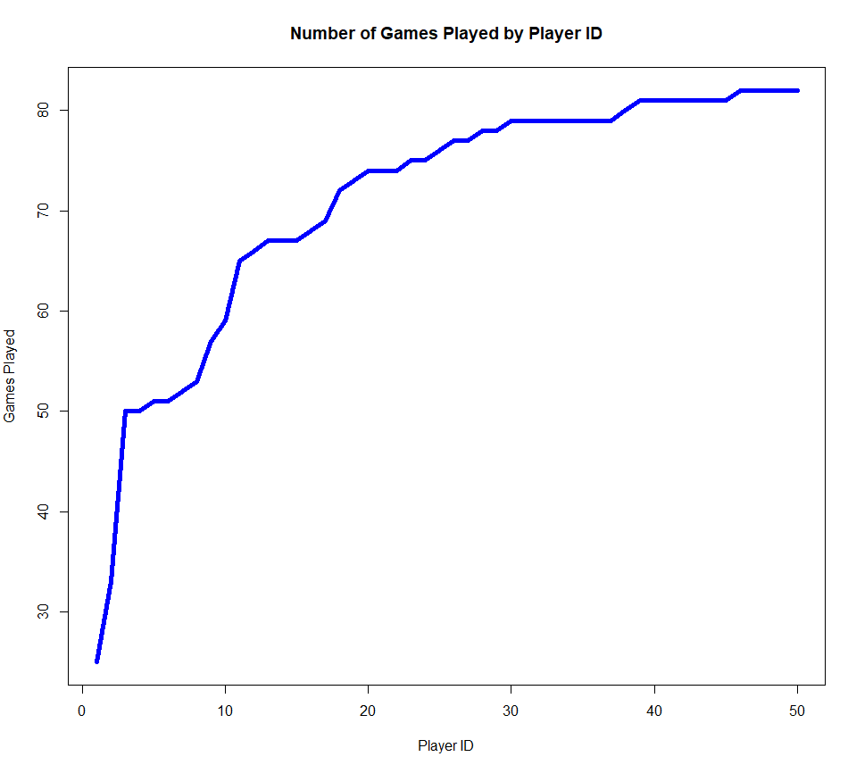

Tableau

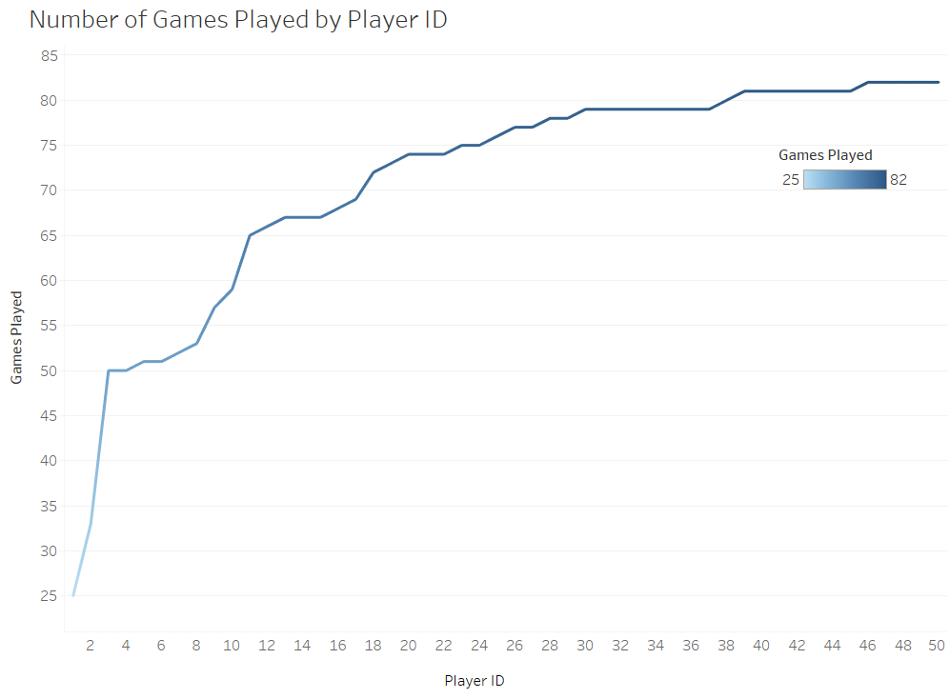

Step Chart

Python

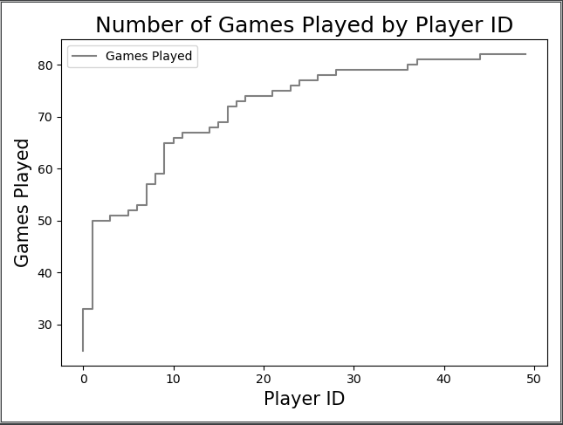

R

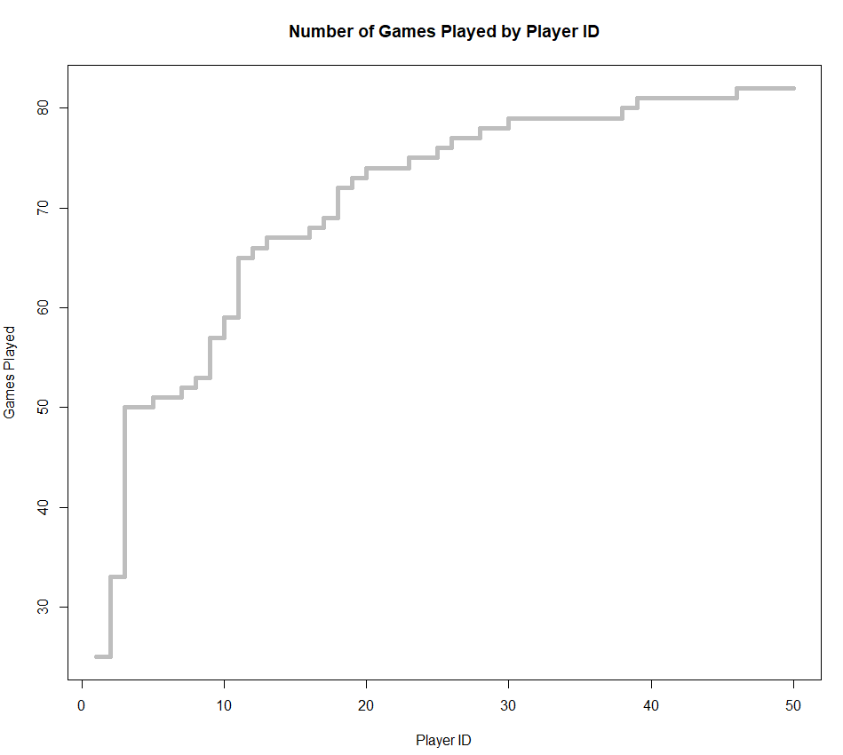

Tableau

